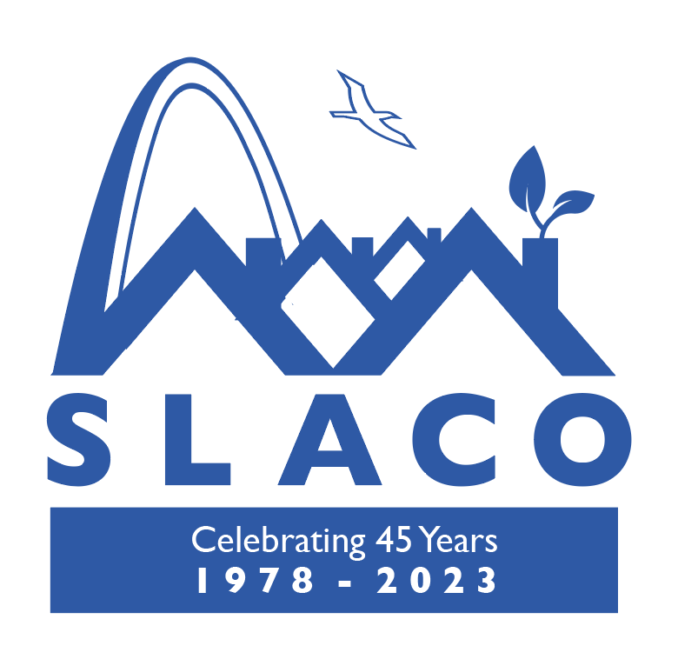

SLACO Committees, January 2023

Finance Committee – Fundraising Committee
Charge: To strengthen the long-term sustainability of SLACO to carry out its mission. Strive for SLACO fiscal self-sufficiency. Create and follow procedures for disbursement of funds and increasing revenues. This standing committee works with the Executive Director immediately on the steps that are necessary to make SLACO more attractive to funders and corporate, foundations, which may include establishing a track record of success with small grants, assuring that SLACO has a current audit, upgrading our outreach and social media presence, and preparing a versatile case statement about why SLACO's work is vital to the broader community. The committee also may find it appropriate and necessary to select some members to make personal appeals for contributions.
Sub Committees Co-chairs to be selected by the committee.
Events: Trivia Night; St. Louis Home Improvement Summit; Groove in The Grove; Regional Neighborhoods Conference; Blues, Brass, and Sass and 45th Sapphire Anniversary
Greg Meyer, Chairperson
Sherri Bailey, Treasurer
Kelley Tribout, Keith Antone Willis, Sr., Consultant

Membership Support Committee
Charge: Assist member neighborhoods to develop new leaders and increase effective networking on key neighborhood issues and assisting with a Neighborhood Association Toolkit. To strengthen member organizations through targeted programs and monitoring of programs. Recruit new members to SLACO. CDA funded programs Neighborhoods United for Change-#NU4Change, Emerging Leaders, Keeping It Clean
Charge: An ad hoc committee to refine and oversee the summer, 2019, implementation of the winning idea from our 250 Ways to Improve Your Neighborhood contest. This program is for interracial exchange and dialogue, with a basis in visits to one another’s neighborhoods.
Town and Gown - Charge: To bring about collaboration between the Universities and Colleges in St. Louis and Neighborhoods
Neighborhood Roundtable - Charge: Develop and implement plans for additional information sharing events, a member benefit to SLACO organizations.
SLACO Regional Neighborhoods Conference - Charge: The ad hoc conference committee joins other community members and professionals in planning the details of the SLACO Regional Neighborhood Conference. The committee will plan the program, invite the presenters, coach the presenters in preparing session descriptions, answer questions from presenters, plan the logistics of the day, and plan and execute marketing and advertising efforts, all with support from the Executive Director. Sub Committees are Logistics, Program, Marketing and Advertising
Sub Committees Co-chairs to be selected by the committee.

Mark Abbott – Chairperson
Mark Abbott, Sherri Bailey, Mark Dowdy, Amanda Davis, Leah Sweetman, Nancy Thompson, Liz Kramer, Robert Strikwerda, Judith Arnold, Mike Reid, Sundy Whiteside,
Other community experts: Craig Schmid – Co Chair Program, Keith Anton Willis Sr. Consultant

Community Development Committee
Charge: To promote urban renewal, neighborhood stabilization and community initiatives to alleviate poverty through advocacy and home improvement.
Home Improvement Summit - Charge: To develop a Conference style event around Home Improvement. Local CDC’s, Businesses, Contractors, Service Providers, City of St. Louis Services, Funders, Legal Services, wrap around services.
STL Vacancy Collaborative, Prop NS, Traffic control and crime reduction initiatives are the responsibility of this Committee. Sub Committees Co-chairs to be selected by the committee.

Sundy Whiteside, Co-Chair – Angela Drake, Co-Chair - Active
Eltoreon Hawkins, Liz Gerard, Abbie Leonard
St. Louis Home Improvement Summit Committee members
Shavette Wayne-Jones – Chair
Amanda Davis, Sundy Whiteside, Angela Drake, Mark Dowdy, Debra Robinson, Pam McLucas, Sheila Webster

Executive Committee – Meet 2nd Monday of the Month – 3:30pm
Charge: Promote “strategic doing” culture and approach within SLACO to advance organization goals and building of supportive collaboration networks. Monitoring of The Strategic Plan. To create and implement a Communications Strategy for SLACO, Stories and outcomes. Review and update By-Laws as needed. Participate in organization capacity building. Nominating of officers and board members. (Report due at December board meeting):

Sundy Whiteside, President - Active
Angela Drake, Secretary
Amanda Davis, Vice President
Sherri Bailey, Treasurer
Mark Dowdy, Sargent of Arms/Parliamentarian
Greg Meyer – Chair, Finance
Mark Abbott – Chair, Membership Support
Leah Sweetman – At Large
Sunni Hutton - VISTA
Brooke Foster is our Webmaster.

Advocacy Issue Selection: was Established in 2015
Charge: This ad hoc committee prepares a recommendation for the Board meeting regarding the major issue to be the focus of SLACO's advocacy efforts for the next three years. The recommendation should describe the topic, the rationale for why it is important, potential allies in the advocacy push, and any specific focus and limitations on the topic that would be wise choices for SLACO. After the issue is adopted, committee members may choose to become part of a standing committee that continues through implementation, but with the understanding that committee members may opt out at that point.
Mark Abbott, Chair - Active
Greg Meyer
Sherri Bailey
Leah Sweetman
Kimberlee Johnson
Some Youth Participants

